# Effect of microwave field on DES

We simulated pure DES (1:1 choline chloride:oxalic acid) using the OPLS force field[1] under alternating electric fields with strengths of E = 0.0, 0.05, 0.075 and 0.1 V/nm and a frequency of 2.45 GHz. The electric field was applied in the x direction. The short range Coulomb and van der Waals cutoff was 1.6 nm, and particle mesh Ewald (PME) was used for long range electrostatics. NVE simulations were run for the cases with electric field for 10 ns using double precision and a time step of 0.5 fs with GROMACS 2018.1[2], allowing us to measure the rate of energy addition for simulations equilibrated at 423.15 K. A 100 ns long NVT simulation at 423.15 K was run for the case of no electric field using a Berendsen thermostat[3] with a time constant of 0.1 ps.

Figure S1 shows the total energy as a function of time for different field strengths. The slopes of total energy as a function of time are 34.45, 105.12, and 192.67 kJ/mol-ns for E = 0.05, 0.075, and 0.1 V/nm, respectively. As expected, these slopes approximately scale with E2. Temperature increases were 0.01, 3.32, and 5.89 K for E = 0.05, 0.075, and 0.1 V/nm, respectively.

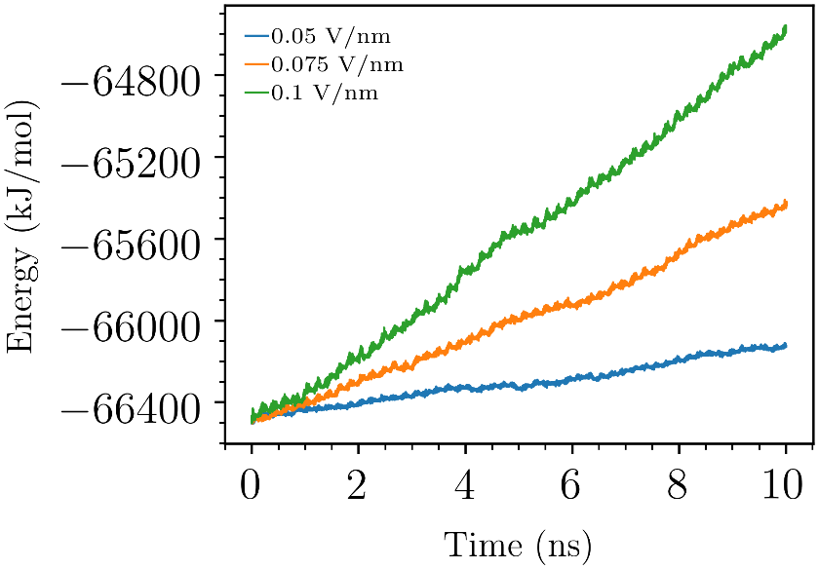

Figure S1: Total energy versus time in NVE simulations of DES.

Time autocorrelation functions (ACFs) were calculated for the angles between choline molecule N-O vectors and the x direction and for the x component of the dipole moment of all choline molecules (Figure S2). The normalized ACFs are then fitted to a sum of two exponential terms where a and $τ$ are constants and t represents time.

$$ACF_{fit}\left(t\right)=ae^{-\frac{t}{τ_{1}}}+(1-a)e^{-\frac{t}{τ_{2}}}$$

An example fit is shown in Figure S2. We use the time integrals of $ACF_{fit}$ from zero to infinity as a means of comparing the ACFs with a smaller number indicating a faster decay of the ACF. The ACFs decay faster with higher electric field intensity as shown in Table S1 and Table S2.

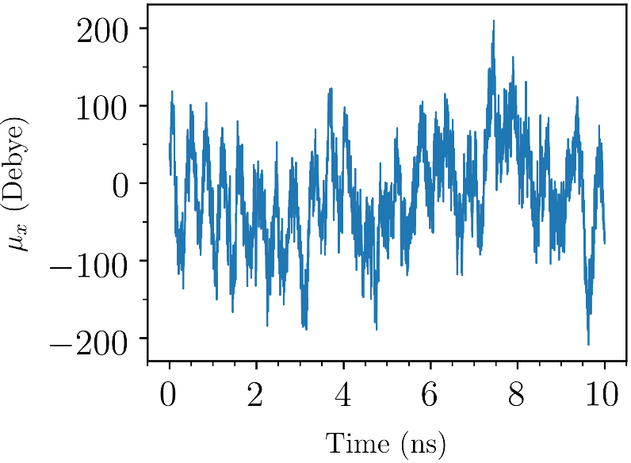

Figure S2: Dipole moment x component ( $μ_{x})$ of all choline molecules in the simulation box versus time.

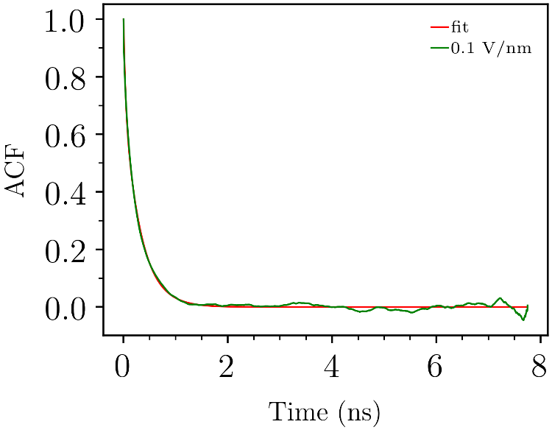

Figure S3: ACF and the corresponding fit for the angle between the choline N-O vectors and the x direction.

Table S1: Integrals of ACF fits (ns) for the angles between choline N-O vectors and the x direction. Config1, Config2, and Config3 refer to simulations with different starting configurations. SE is the standard error of the mean.

|  |  |  |  |  |
| --- | --- | --- | --- | --- |
| Field strength | 0.0 V/nm | 0.05 V/nm | 0.075 V/nm | 0.1 V/nm |
| Config1 | 256.8 | 254.8 | 258.5 | 242.6 |
| Config2 | - | 246.6 | 233.6 | 235.1 |
| Config3 | - | 236.0 | 239.5 | 219.9 |
| Mean | - | 245.8 | 243.9 | 232.5 |
| SE | - | 5.4 | 7.5 | 6.6 |

Table S2: Integrals of ACF fits (ns) for the dipole moment of all choline molecules. Config1, Config2, and Config3 refer to simulations with different starting configurations. SE is the standard error of the mean.

|  |  |  |  |  |
| --- | --- | --- | --- | --- |
| Field strength | 0.0 V/nm | 0.05 V/nm | 0.075 V/nm | 0.1 V/nm |
| Config1 | 263.72 | 266.3 | 270.7 | 261 |
| Config2 | - | 253.5 | 232.5 | 218.1 |
| Config3 | - | 245.6 | 253.3 | 224.6 |
| Mean | - | 255.1 | 252.2 | 234.6 |
| SE | - | 6.0 | 11.0 | 13.3 |

# Effect of microwave field on lignin bond lengths

Files are included with the values of bond length differences for all bonds considered. The “System” column refers to the type of lignin tetramer where bo4-RRSSRS and bo4-RRRSRS are the isomers with all β-O-4 linkages and b5 is the tetramer with β-O-4, β-5, β-O-4 linkages. The “Bond num” column refers to the bond numbers shown in Figure 2 in the paper. The “Mean bond len diff (nm)” column refers to the difference in the mean bond length (E = 0.1 V/nm – E = 0.0 V/nm). The “Mean bond len diff unc (a=0.05)” column is half the width of the 95% confidence intervals for the mean difference. In addition to the difference between mean bond lengths, the right tail of the distributions was also analyzed since a significant difference in the means may not necessarily lead to a significant difference in the tails. The right tail with the longest bond lengths is the most important part when considering whether bonds will more frequently break or not. For analyzing the right tail, we found the bond length for the 99th percentile (dcut) of the distribution with E = 0.0 V/nm. This cutoff is in the “Bond length cutoff (nm)” column. We then found the probability of the bond length being greater than dcut for E = 0.1 V/nm, P(d > dcut | E = 0.1 V/nm). The difference between the probabilities for the two field strengths is just P(d > dcut | E = 0.1 V/nm) – 0.01. This difference is in the “P > cutoff diff” column and half the width of the 95% confidence intervals is in the “P > cutoff diff unc (a=0.05)” column. In all cases, we see that if there is a significant difference in the means, then there is also a significant difference in the right tails. The distributions are mostly just shifted; their shapes do not change significantly. The bond_lengths.csv file contains all the bonds. The bond_lengths_sig_chng.csv file contains only bonds where the magnitude of the difference in mean bond length is greater than the uncertainty. The bond_lengths_sig_inc.csv file contains only bonds where there is an increase in the mean bond length with the electric field turned on and the difference in mean bond length is greater than the uncertainty. The uncertainties were computed with a method based on the one in the appendix of [4]. Instead of using a constant prefactor, we allow the prefactor to vary to obtain better fits to the standard error as a function of block length. In addition, instead of using only one set of blocks for each length, we use the stationary bootstrap method [5] to sample 200 sets of blocks for each block length considered. This reduces the noise in the data significantly and therefore improves the estimate of the infinite block length standard error. The python code used for the analysis is in confidence_interval.py. An example of using this code is:

cutoff=`cat ../analysis/bo4-RRSSRS/0.0/1/cutoff.dat`

python ../scripts/confidence_interval.py npy_files/bo4-RRSSRS/0.0/bond_dist_time.npy 1 -op ../analysis/bo4-RRSSRS/0.0/1/bond_dist_ -od ../analysis -sk 3 -vp -mb 24 -bsn 100 -nb 200 -cf "lambda x: np.hstack((np.mean(x), np.sum(x > $cutoff)/x.shape[0]))"

The mean bond lengths and differences in mean bond lengths are also shown in Table S3, Table S4, and Table S5. The bond length probability density bond 6 in the b5 system is plotted in Figure S4, showing a small shift towards longer bond lengths with E = 0.1 V/nm relative to E = 0.0 V/nm.

Table S3: bo4-RRSSRS bond length means and differences in means.

|  |  |  |  |
| --- | --- | --- | --- |
| **Bond num** | **Bond length difference** | **Bond length mean E = 0.0 V/nm** | **Bond length mean E = 0.1 V/nm** |
| **1** | -2.1E-04 | 0.15389 | 0.15368 |
| **2** | -5.4E-05 | 0.15450 | 0.15445 |
| **3** | 1.3E-05 | 0.14871 | 0.14872 |
| **4** | -1.3E-04 | 0.13885 | 0.13871 |
| **5** | 7.0E-05 | 0.15375 | 0.15382 |
| **6** | 1.7E-04 | 0.15448 | 0.15465 |
| **7** | 2.0E-04 | 0.14862 | 0.14882 |
| **8** | -1.9E-05 | 0.13870 | 0.13868 |
| **9** | 8.6E-05 | 0.15348 | 0.15357 |
| **10** | -2.4E-04 | 0.15468 | 0.15444 |
| **11** | -9.1E-05 | 0.14870 | 0.14861 |
| **12** | -3.5E-05 | 0.13860 | 0.13856 |

Table S4: bo4-RRRSRS bond length means and differences in means.

|  |  |  |  |
| --- | --- | --- | --- |
| **Bond num** | **Bond length difference** | **Bond length mean E = 0.0 V/nm** | **Bond length mean E = 0.1 V/nm** |
| **1** | -6.1E-05 | 0.15377 | 0.15371 |
| **2** | 9.0E-05 | 0.15452 | 0.15461 |
| **3** | -3.2E-05 | 0.14870 | 0.14867 |
| **4** | -2.0E-04 | 0.13895 | 0.13875 |
| **5** | -2.0E-04 | 0.15360 | 0.15340 |
| **6** | 4.8E-05 | 0.15449 | 0.15454 |
| **7** | -7.8E-05 | 0.14871 | 0.14863 |
| **8** | -1.4E-04 | 0.13871 | 0.13857 |
| **9** | 2.9E-04 | 0.15365 | 0.15394 |
| **10** | 2.4E-04 | 0.15440 | 0.15464 |
| **11** | 7.7E-05 | 0.14874 | 0.14882 |
| **12** | 3.3E-06 | 0.13868 | 0.13868 |

Table S5: b5 bond length means and differences in means.

|  |  |  |  |
| --- | --- | --- | --- |
| **Bond num** | **Bond length difference** | **Bond length mean E = 0.0 V/nm** | **Bond length mean E = 0.1 V/nm** |
| **1** | -4.1E-04 | 0.15383 | 0.15342 |
| **2** | -3.2E-05 | 0.15434 | 0.15431 |
| **3** | 3.4E-05 | 0.14863 | 0.14866 |
| **4** | -9.4E-05 | 0.13867 | 0.13857 |
| **5** | -3.9E-04 | 0.15260 | 0.15221 |
| **6** | 3.6E-04 | 0.15622 | 0.15658 |
| **7** | 5.6E-05 | 0.15151 | 0.15156 |
| **8** | 1.1E-04 | 0.13942 | 0.13953 |
| **9** | -1.0E-04 | 0.13853 | 0.13843 |
| **10** | -1.4E-04 | 0.14663 | 0.14649 |
| **11** | -3.0E-05 | 0.15407 | 0.15404 |
| **12** | 5.3E-06 | 0.15451 | 0.15452 |
| **13** | -7.8E-05 | 0.14877 | 0.14869 |
| **14** | -1.1E-05 | 0.13867 | 0.13866 |

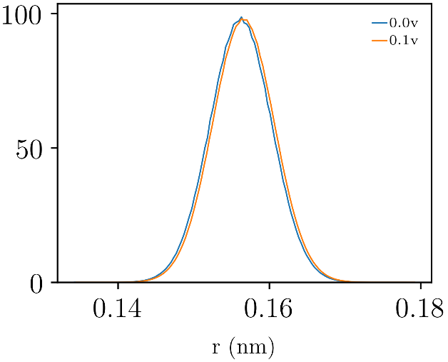

Figure S4: Bond length probability density distributions for b5 bond 6 with E = 0.0 V/nm and E = 0.1 V/nm.

Uncategorized References

1. Jorgensen, W.L., D.S. Maxwell, and J. Tirado-Rives, *Development and testing of the OPLS all-atom force field on conformational energetics and properties of organic liquids.* Journal of the American Chemical Society, 1996. **118**(45): p. 11225-11236.

2. Abraham, M.J., et al., *GROMACS: High performance molecular simulations through multi-level parallelism from laptops to supercomputers.* SoftwareX, 2015. **1**: p. 19-25.

3. Berendsen, H.J., et al., *Molecular dynamics with coupling to an external bath.* The Journal of chemical physics, 1984. **81**(8): p. 3684-3690.

4. Hess, B., *Determining the shear viscosity of model liquids from molecular dynamics simulations.* The Journal of chemical physics, 2002. **116**(1): p. 209-217.

5. Politis, D.N. and J.P. Romano, *A circular block-resampling procedure for stationary data.* Exploring the limits of bootstrap, 1992. **2635270**.